Navbar and Footer Instruction
Step1: Cite files
Head:
<!-- bootstrap css -->
<link rel="stylesheet" href="../css/bootstrap.min.css">
<!-- google font Roboto, Great Vibes -->
<link rel="preconnect" href="https://fonts.googleapis.com">
<link rel="preconnect" href="https://fonts.gstatic.com" crossorigin>
<link href="https://fonts.googleapis.com/css2?family=Poppins:ital,wght@0,100;0,200;0,300;0,400;0,500;0,600;0,700;0,800;0,900;1,100;1,200;1,300;1,400;1,500;1,600;1,700;1,800;1,900&family=Roboto:ital,wght@0,100..900;1,100..900&display=swap" rel="stylesheet">
<link rel="preconnect" href="https://fonts.googleapis.com">
<link rel="preconnect" href="https://fonts.gstatic.com" crossorigin>
<link href="https://fonts.googleapis.com/css2?family=Great+Vibes&family=Poppins:ital,wght@0,100;0,200;0,300;0,400;0,500;0,600;0,700;0,800;0,900;1,100;1,200;1,300;1,400;1,500;1,600;1,700;1,800;1,900&family=Roboto:ital,wght@0,100..900;1,100..900&display=swap" rel="stylesheet">
<!-- iconfont -->
<link rel="stylesheet" href="../icon/font_5133841_yoi6izyebpl/iconfont.css">
<link rel="stylesheet" href="../css/navbar.css">
<link rel="stylesheet" href="../css/footer.css">

At the end of body:
<script src="../icon/font_5133841_yoi6izyebpl/iconfont.js"></script>
<script src="../js/navbar.js"></script>

Note: Please ensure the file paths are correct.
Step2.Copy the html code of navbar and footer
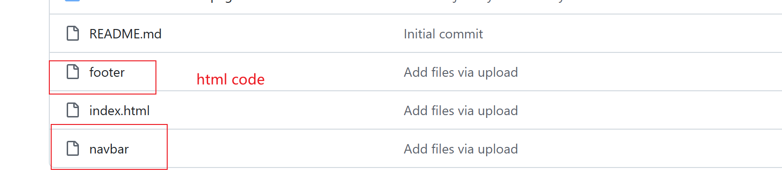
Step3:modify the code of navbar
Note: only About , rooms , myaccount page need to do this step.
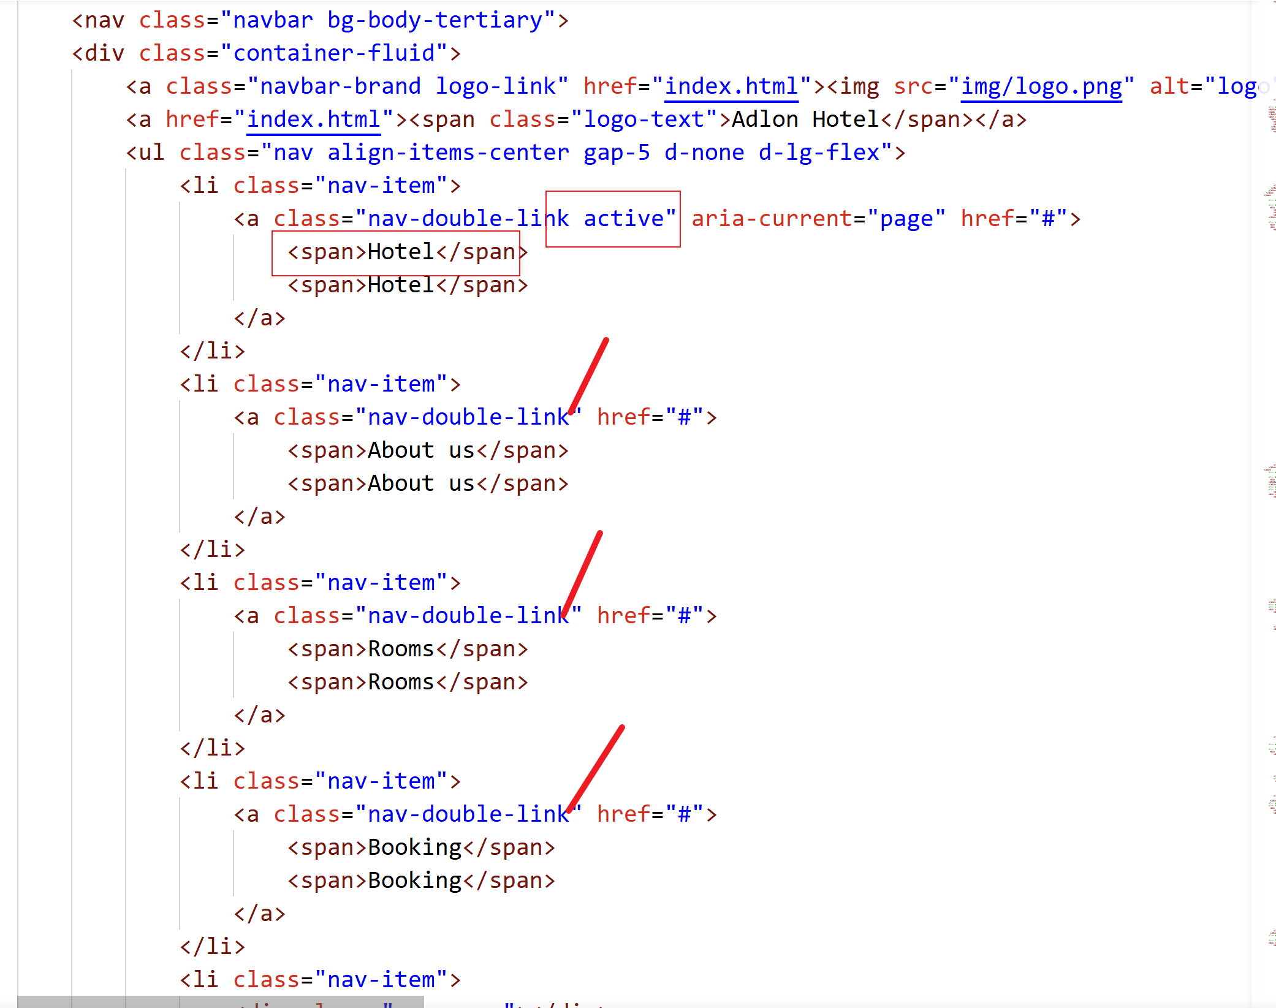
Add "active" to the corresponding page. For example, my page is the main Hotel page, I need to add "active" to the class name. If your page is the About Us page, you need to remove "active" from the Hotel page and add "active" to the class name on the about us page.
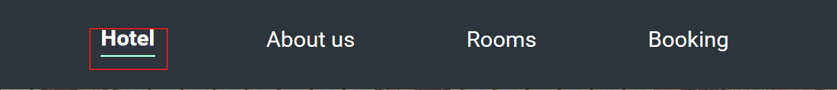
When you see a green underline below the corresponding page in the navbar, it proves that your modification is successful.
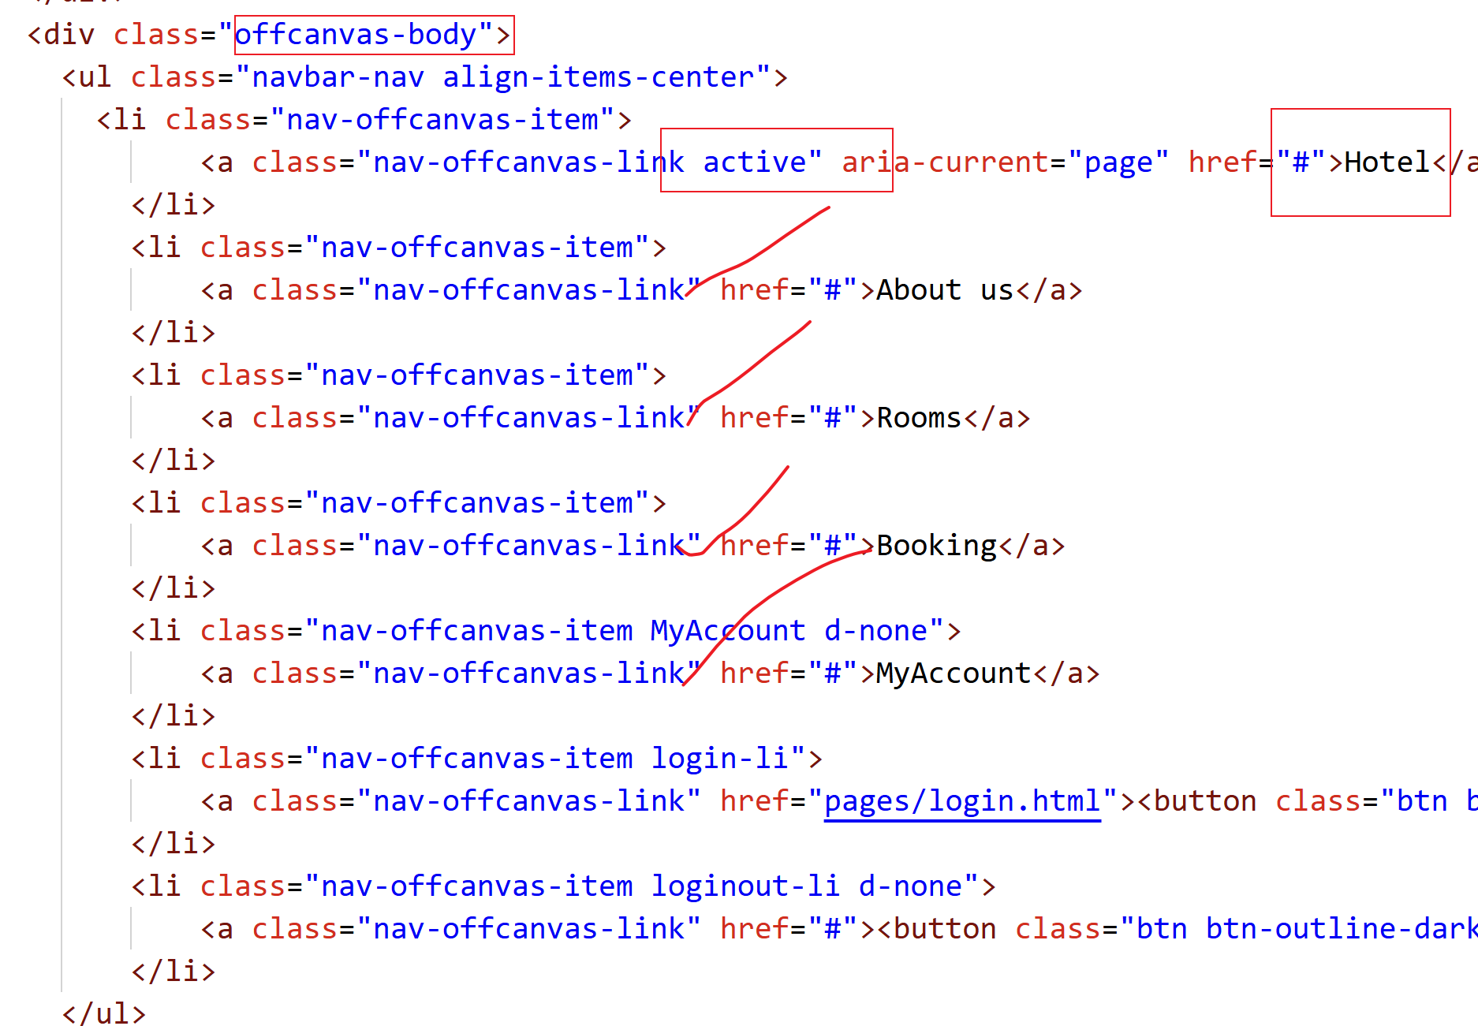
The operation is the same as above. Add "active" in the corresponding place according to the page name.
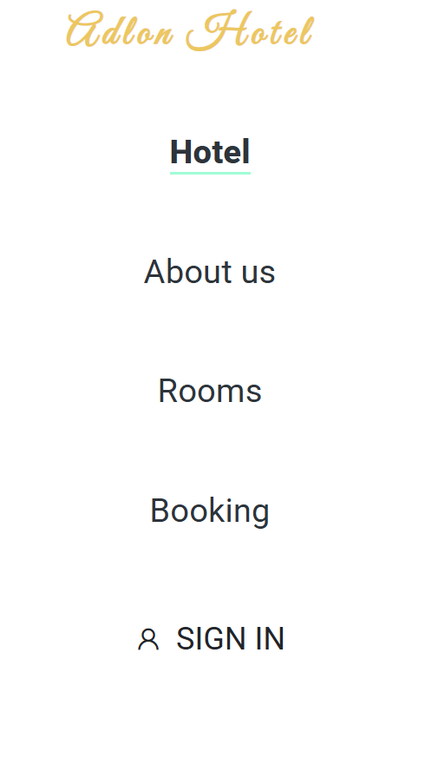
Under your page name, seeing a green underline means the modification is successful.

